Positon Applied For:

Personal Details: (Please Print)
Surname:
First Name/s:
Residential Address:
Email Address:
Telephone:
Date of Birth:
(Applies only for applicants
between 16 & 21yrs of age)
Do you identify as Aboriginal/Torres Strait Islander: Yes No
Do you come from a Non-English speaking background (NESB): Yes No
If yes, What is your primary language:

Medical / Disability Yes No
Do you have a disability or medical condition that may affect your ability to carry out the requirements of this position, and that may require reasonable modification to the role? If so, give details below:
Are you willing to undergo a medical examination and / or immunisations relevant to specific positions at Council’s expense prior to employment confirmation? Yes No
(Please note: The medical examination will include a Drug and Alcohol test)

General
Do you hold?
- Current Queensland Drivers Licence Yes No
Please attach a copy
- White Card (Prepare to work safely in the construction industry) Yes No
Please attach a copy
- Blue Card (Working with children) Yes No
Please attach a copy
References / Referees
List names, address and telephone contact numbers of Three (3) work referees from whom confidential reports may be obtained.
1.
2.
3.

General Conditions of Service
General conditions of service relating to employment with Council as listed below for your perusal and if employed you will be required to adhere to same.
- All employees are to comply with a “Smoke Free” policy in all Council buildings and vehicles;
- All employees are to adhere to the provisions of Council’s Workplace Health and Safety Policy at all times including the wearing of Personal Protective Equipment when applicable and / or when directed to do so;
- Council Vehicles are to be used for official duties only and under circumstances are unauthorised persons allowed to ride them with previous approval from the Chief Executive Officer;
- All normal wages/salaries are paid fortnightly direct to a bank account acceptable to Council and to be notified by the employee within two (2) days of engagement;
- No overtime is worked without express prior approval being given by Council or its designated Officer and then only on application with the approval timesheet;
- A Probationary period of three (3) months applies to most positions with Council.

Mount Isa City Council is collecting your personal information on this form in order to comply with its responsibilities and obligation as a Local Government. The information will only be accessed by authorised Council employees who have a legitimate need for the information to process applications, requests etc. Your personal information will not be given to any other person or agency unless you have given us permission to do so, or we are required to do so by law.

Selection Criteria Example
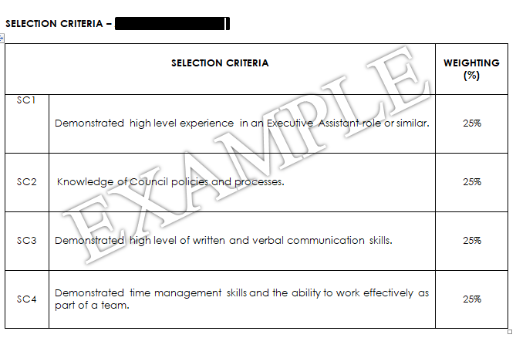

Located at the back of the position description is a table as shown above. You are required to provide written demonstrated experience to each of the criteria individually.
Checklist
I have addressed the Key selection Criteria found in the back of the position description;
I have attached copies of all relevant Qualifications, Licences and Tickets etc;
I have attached a copy of my resume.
Please be advised all applications will be accepted by Human Resources or alternatively you can email an electronic application to hr@mountisa.qld.gov.au .
Certification
I certify that the information given in this application is true and correct, and that if employed, such information as stated, forms the basis of my contract of service with Council.
Signature of Application:
Date:

